Extended Abstract - Title in Title Case (Font: Arial 18 bold)

First Author Smith^{1,}, Second Author² and Third Author³
¹ Full affiliation (Department, Organization, Country)
² Full affiliation (Department, Organization, Country)
³ Full affiliation (Department, Organization, Country)
(use Arial 10 typeface for author’s Affiliation)

ABSTRACT
This file provides a template for writing papers for the conference. The conference proceedings will be published in an electronic format. The full paper file shall be written in compliance with these instructions. The author is asked to submit the paper in MS-Word. An abstract not exceeding 300 words, should appear on the top of the first page, after the title of the paper in the chapter titled "Abstract" (without chapter number), after the names of the authors and the contact information of the corresponding author.

Keywords: Keyword1; Keyword 2; …..(Maximum 5 Keywords).

1. INTRODUCTION
It is expected that authors will submit carefully written and proofread material. Spelling and grammatical errors, as well as language usage problems, are not acceptable in the final submission. There is no strict limitation to the number of pages, but it is suggested that the paper length should not exceed 6000 words.
Papers should clearly describe the background of the subject, the authors’ work, including the methods used along with the results and concluding to a discussion on the importance of the work. Papers are to be prepared in English (British or American). Technical terms should be explained. Acronyms should be written out at their first appearance.

2. paper format
The uniform outlook will help the reader to follow the proceedings. This can be obtained most easily if authors use this template file to construct their papers. Please note the following details: this template is an A4 format. All text paragraphs should be single spaced, with the first line intended by 10 mm (0.4 inches). Double spacing should only be used before and after headings and subheadings as shown in this example. Position and style of headings and subheadings should follow this example. No spaces should be placed between paragraphs. Please do not change any of the page, paragraph and font settings.

2.1. Fonts
Papers should use 11-point Georgia font. The styles available are bold, italic and underlined.
It is recommended that text in figures is not smaller than 10-point font size.

3.2. Tables and Figures
Figure captions and table headings should be sufficient to explain the figure or table without needing to refer to the text. Figures and tables not cited in the text should not be presented. Styles Heading Table and Caption Figure are available in this template for tables and figures. The following is the example for Table 1.
Table 1 Title of Example Table
Code | Items
 | Item 01 | Item 02 | Item 03 | Item 04
Code 1 | 29.53 | 44.58 | 41.05 | 23.81
Code 2 | 60.4 | 60.92 | 60.47 | 38.24

Tables and figures should be placed close after their first reference in the text. All figures and tables should be numbered with Arabic numerals. Table headings should be above the tables. Figure captions should be centred below the figures.

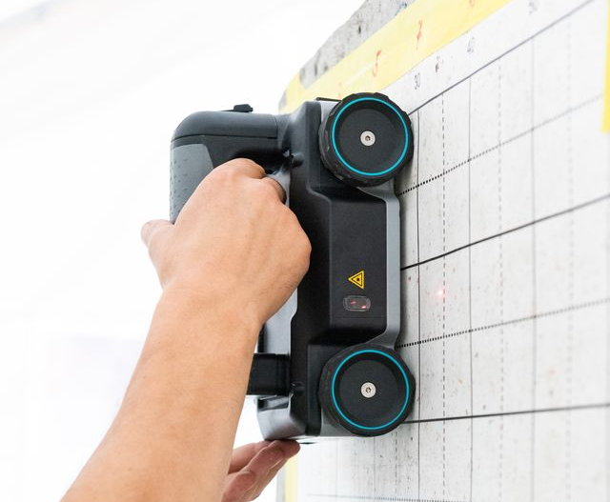
Figure 1. Ground Penetrating Radar (GPR)

acknowledgements
List here the persons, organisations etc. you would like to acknowledge if applicable.

REFERENCES
List of references must follow IEEE style.
For more information, please visit: https://ieeeauthorcenter.ieee.org/wp-content/uploads/IEEE-Reference-Guide.pdf

Corresponding author: phone and email

